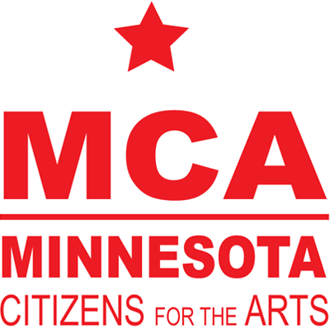

CONTACT:
Jennifer Weismann
612-716-0556
jennifer@owl-marketing.com

MINNESOTA CITIZENS FOR THE ARTS SELECTS
SARAH FOSSEN AS EXECUTIVE DIRECTOR
Transformative marketer, inclusivity driver and arts enthusiast
joins arts advocacy organization — from Rosedale Center

MINNEAPOLIS — July 14, 2021 — Arts advocacy organization Minnesota Citizens for the Arts (MCA) announces the hire of Sarah Fossen as executive director, beginning August 1. Fossen—known for her ability to create high-profile awareness around issues and organizations, non-traditional partnerships, and high level strategic results—replaces Sheila Smith, who stepped down in February after 25 years leading the group. Consultant Jennifer Halcrow served as interim director during the national search.

Fossen joins MCA from JLL/Rosedale Center, where she served as director of marketing and experience. In that role, she worked to reinvent traditional retail marketing with thoughtful and disruptive strategies that drove sales and increased traffic, and helped create social equity by hosting inclusive initiatives. Prior to Rosedale, Fossen served in marketing leadership roles at the City of St. Paul and Capital City Partnership (now Greater MSP) until starting her own marketing communications firm, Agency NORD. She also worked at Augsburg University, where she led government relations, community relations and other advancement departments. She holds bachelor of arts degrees in PR/Marketing and Art from Concordia College-Moorhead and is a native of Glenwood, Minn.

MCA, considered the strongest arts advocacy group in the United States, has worked relentlessly to increase state support for the arts across Minnesota. In 2008, it helped create and pass the Legacy Amendment, tripling arts funding in Minnesota to more than $35M annually, granted through the State Arts Board and Regional Arts Council system. MCA also developed Creative Minnesota, a collaboration of statewide foundations and arts-supporting organizations to gather and analyze hard data to use for advocacy, education and policymaking. According to 2019 MCA research, the arts had a $1.5 billion annual economic impact on the State of Minnesota.

“I’m honored to join Minnesota Citizens for the Arts — I’ve worked in government, retail, private sector, nonprofit and higher education, and I’ve owned my own business— now I’m looking forward to merging those experiences to continue to accelerate the reach and influence of the organization,” says Sarah Fossen, new executive director of Minnesota Citizens for the Arts. “Growing up in Central Minnesota, attending college in Western Minnesota and spending time throughout the state, I have experienced first-hand the importance of arts as an economic driver. I intend to use my government relations background to protect and enhance arts funding and my marketing experience to engage arts enthusiasts in all corners of the state. My life-long passion for the arts will fuel this important work.”

“The diverse strengths that Sarah is bringing MCA, including a vision for creative and new strategic alliances for the organization, as well as her proven savvy with social media and government relations, are very exciting — we’re thrilled to have her on board,” says Mary Ann Aufderheide, MCA board co-chair. “Her career-long focus on creating community and supporting art — bringing people together to develop a sense of meaningful engagement — was a huge factor in our decision. We look forward to continuing our support, under Sarah’s leadership, of diverse statewide arts and cultural organizations as they get back up and running post-pandemic.”

“Sarah’s range of work and life experiences will deliver unexpected partners and opportunities to MCA — we can’t wait for her new ideas and approaches,” adds Ross Willits, MCA board co-chair. “MCA will remain laser-focused on ensuring the state provides adequate and equitable funding for the arts across the entire state. While the goal remains the same, Sarah will bring new tactics and different approaches to coalition-building and communication. Her breadth of experience will help create community and support art for Minnesotans in every corner of the state.”

A search committee composed of diverse members of the MCA board worked with search firm Ballinger Leafblad to find its new executive director.

The mission of Minnesota Citizens for the Arts is to ensure access to the arts for all Minnesotans. MCA supports Minnesota's arts community by lobbying the legislature and Congress on behalf of the nonprofit arts and artists. MCA is best known for its Annual Arts Advocacy Day at the State Capitol. MCA strengthens Minnesota’s cultural community by achieving arts-friendly policy and by creating original research that can be used in advocating for the arts. For more, visit www.artsmn.org and www.creativeMN.org.

###

